Assignment 2 : Interactive Recipe Card with Animations

PROJECT DESCRIPTION

The Interactive Recipe Website is a responsive and user-friendly web application designed to help users explore a variety of recipes in an attractive and interactive way. The website displays multiple recipes such as Chocolate Cake, Chicken Biryani, Creamy Pasta, Homemade Pizza, Pancakes, Vegetable Fried Rice, Hakka Noodles, and Gulab Jamun.
Each recipe provides important details including the recipe image, category, preparation time, serving size, difficulty level, ingredients, and step-by-step cooking instructions. Users can search for recipes, filter them by category, open a detailed recipe view, and interact with cooking-related features.
The project is developed using HTML, CSS, and JavaScript. HTML is used to structure the website, CSS is used for responsive layouts, styling, transitions, hover effects, and animations, while JavaScript provides dynamic functionality and user interaction.
The main objective of this project is to create a visually appealing recipe platform that demonstrates practical knowledge of frontend web development, responsive design, DOM manipulation, event handling, CSS animations, and basic JavaScript interactivity.

KEY FEATURES

- Multiple Recipe Collection — Displays several recipes instead of a single recipe card, making the assignment function like a complete recipe website.
- Recipe Search Functionality — Allows users to search for recipes by entering recipe names or related keywords.
- Category-Based Filtering — Users can filter recipes based on categories such as Dessert, Main Course, Italian, Breakfast, Fast Food, and Chinese.
- Interactive Recipe Cards — Each recipe is displayed as an attractive card containing an image, recipe name, category, preparation time, and other useful information.
- Detailed Recipe Modal — Clicking a recipe opens a detailed view containing the recipe description, ingredients, preparation steps, serving information, and difficulty level.
- Ingredients Toggle — Users can show or hide the ingredients list using an interactive button.
- Step-by-Step Cooking Instructions — Recipes provide structured cooking instructions so users can follow each preparation step clearly.
- Start Cooking Feature — Users can begin an interactive cooking flow and move through recipe steps one by one.
- Animated Progress Bar — A progress indicator visually shows how much of the cooking process has been completed.
- Cooking Timer — Includes timer functionality to support users during recipe preparation.
- Favorite Recipes — Users can mark selected recipes as favorites and access them separately.
- Responsive Web Design — The website adapts to desktop, tablet, and mobile screen sizes using CSS media queries.
- CSS Animations and Transitions — Hover effects, smooth transitions, card animations, and interactive visual feedback improve the user experience.
- Recipe Images — Each recipe includes a relevant food image to make the website visually engaging.
- Mobile Navigation Menu — Provides a responsive navigation experience for smaller screens.

TECHNOLOGIES USED

- HTML5 — Creates the structure and semantic layout of the website.
- CSS3 — Handles styling, responsive design, animations, transitions, and hover effects.
- JavaScript — Manages recipe data, search, filtering, modal interactions, favorites, timer functionality, and cooking progress.
- CSS Media Queries — Ensures responsive behavior across different devices.
- Local Storage — Can preserve favorite recipe selections in the browser, if enabled in your current code.

OUTPUT EVIDENCE (SCREENSHOTS)

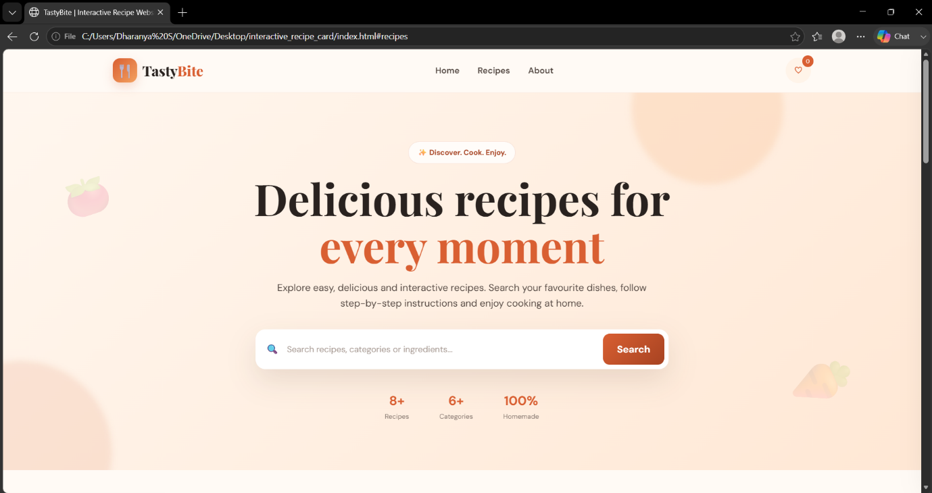

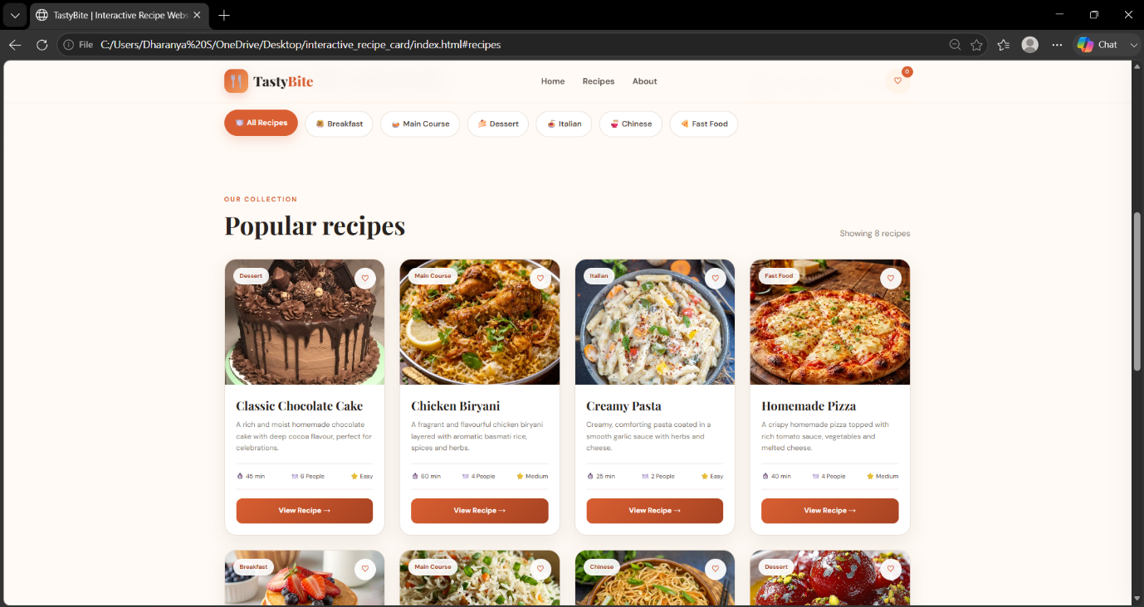

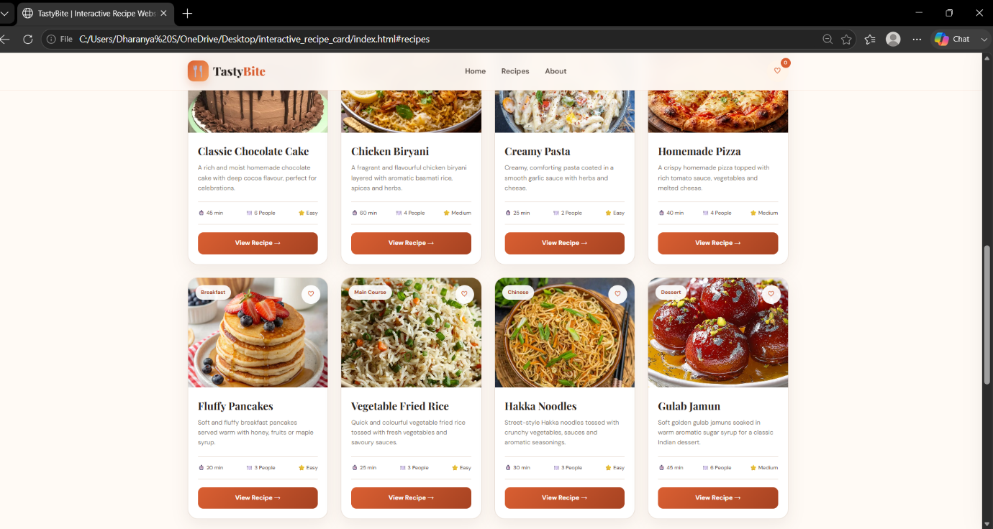

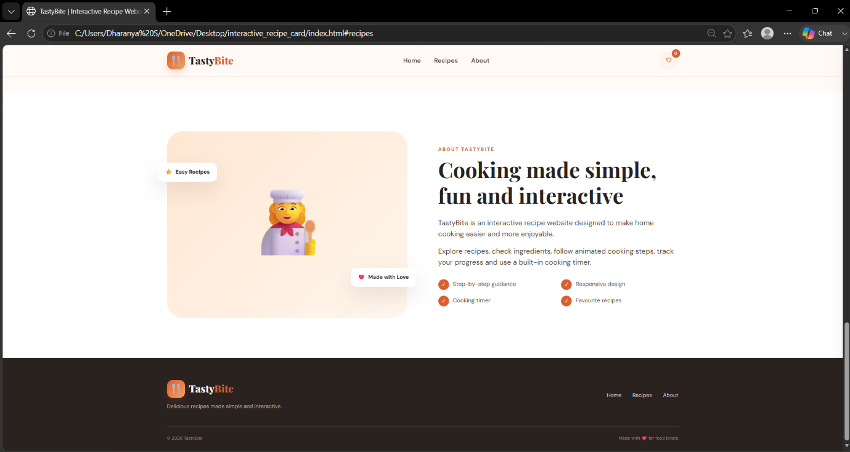

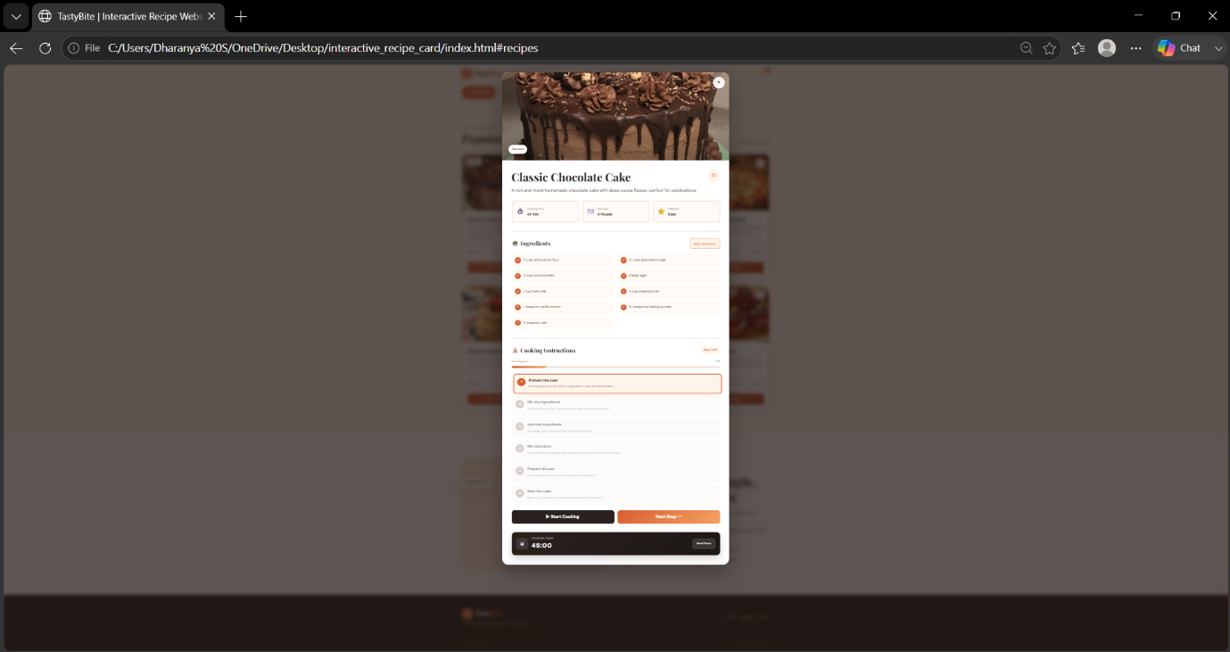

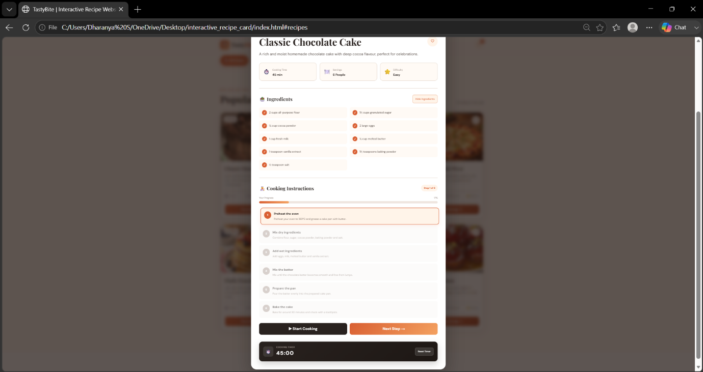

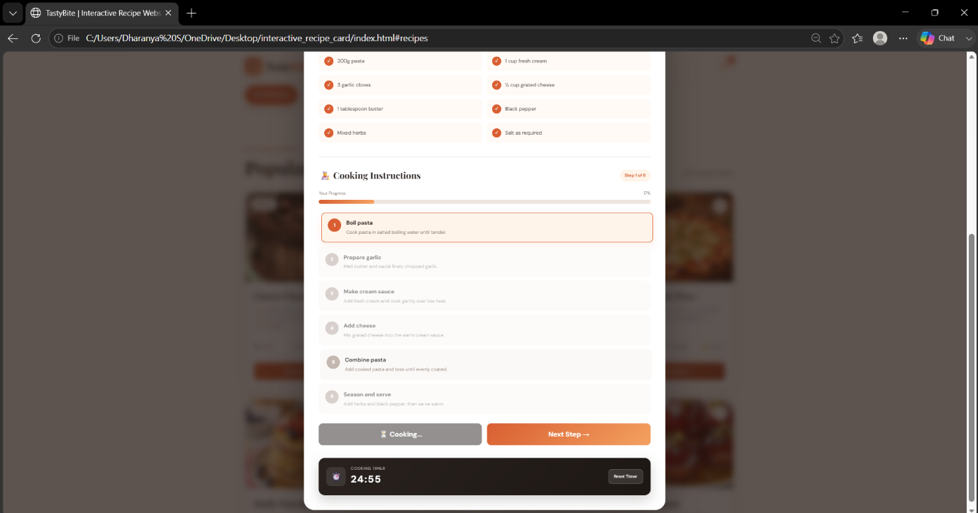

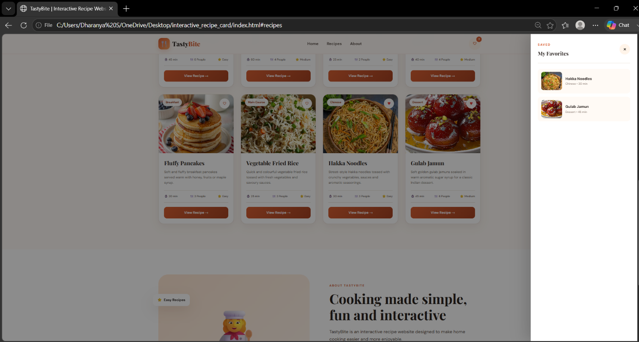

SOURCE CODE

File 1 : index.html

<!DOCTYPE html>

<html lang="en">

<head>

<meta charset="UTF-8">

<meta

name="viewport"

content="width=device-width, initial-scale=1.0"

>

<meta

name="description"

content="TastyBite interactive multi-recipe website"

>

<title>TastyBite | Interactive Recipe Website</title>

<!-- Google Fonts -->

<link rel="preconnect" href="https://fonts.googleapis.com">

<link rel="preconnect" href="https://fonts.gstatic.com" crossorigin>

<link

href="https://fonts.googleapis.com/css2?family=DM+Sans:wght@400;500;600;700&family=Playfair+Display:wght@600;700;800&display=swap"

rel="stylesheet"

>

<!-- CSS -->

<link

rel="stylesheet"

href="style.css"

>

</head>

<body>

<!-- =========================================

NAVBAR

========================================== -->

<header class="navbar">

<div class="nav-container">

<a

href="#home"

class="logo"

>

<span class="logo-icon">

🍴

</span>

<span>

Tasty<span class="logo-highlight">Bite</span>

</span>

</a>

<nav

class="nav-links"

id="navLinks"

>

<a href="#home">

Home

</a>

<a href="#recipes">

Recipes

</a>

<a href="#about">

About

</a>

</nav>

<div class="nav-actions">

<button

class="nav-icon-button"

id="favoriteNavBtn"

type="button"

aria-label="Open favorites"

>

♡

<span id="favoriteCount">

0

</span>

</button>

<button

class="menu-button"

id="menuBtn"

type="button"

aria-label="Open navigation menu"

>

☰

</button>

</div>

</div>

</header>

<!-- =========================================

HERO

========================================== -->

<main>

<section

class="hero"

id="home"

>

<div class="hero-decoration hero-decoration-one"></div>

<div class="hero-decoration hero-decoration-two"></div>

<div class="hero-content">

<span class="hero-badge">

✨ Discover. Cook. Enjoy.

</span>

<h1>

Delicious recipes for

<span>every moment</span>

</h1>

<p>

Explore easy, delicious and interactive recipes.

Search your favourite dishes, follow step-by-step

instructions and enjoy cooking at home.

</p>

<div class="hero-search">

<span class="search-icon">

🔍

</span>

<input

type="search"

id="searchInput"

placeholder="Search recipes, categories or ingredients..."

autocomplete="off"

>

<button

id="searchBtn"

type="button"

>

Search

</button>

</div>

<div class="hero-stats">

<div>

<strong>8+</strong>

<span>Recipes</span>

</div>

<div>

<strong>6+</strong>

<span>Categories</span>

</div>

<div>

<strong>100%</strong>

<span>Homemade</span>

</div>

</div>

</div>

</section>

<!-- =========================================

CATEGORIES

========================================== -->

<section class="categories-section">

<div class="section-container">

<div class="section-heading">

<div>

<span class="section-label">

EXPLORE

</span>

<h2>

Browse by category

</h2>

</div>

<p>

Find the perfect recipe for every craving.

</p>

</div>

<div class="category-buttons">

<button

class="category-btn active"

data-category="All"

type="button"

>

🍽️ All Recipes

</button>

<button

class="category-btn"

data-category="Breakfast"

type="button"

>

🥞 Breakfast

</button>

<button

class="category-btn"

data-category="Main Course"

type="button"

>

🍛 Main Course

</button>

<button

class="category-btn"

data-category="Dessert"

type="button"

>

🍰 Dessert

</button>

<button

class="category-btn"

data-category="Italian"

type="button"

>

🍝 Italian

</button>

<button

class="category-btn"

data-category="Chinese"

type="button"

>

🍜 Chinese

</button>

<button

class="category-btn"

data-category="Fast Food"

type="button"

>

🍕 Fast Food

</button>

</div>

</div>

</section>

<!-- =========================================

RECIPES

========================================== -->

<section

class="recipes-section"

id="recipes"

>

<div class="section-container">

<div class="section-heading">

<div>

<span class="section-label">

OUR COLLECTION

</span>

<h2>

Popular recipes

</h2>

</div>

<p id="recipeResultText">

Showing 8 recipes

</p>

</div>

<!-- JavaScript inserts cards here -->

<div

class="recipe-grid"

id="recipeGrid"

></div>

<!-- Empty Search State -->

<div

class="empty-state hidden"

id="emptyState"

>

<span>

🔍

</span>

<h3>

No recipes found

</h3>

<p>

Try another search term or category.

</p>

<button

id="clearSearchBtn"

type="button"

>

Show All Recipes

</button>

</div>

</div>

</section>

<!-- =========================================

ABOUT

========================================== -->

<section

class="about-section"

id="about"

>

<div class="section-container about-grid">

<div class="about-visual">

<div class="about-emoji">

👩‍🍳

</div>

<div class="floating-card floating-one">

<span>⭐</span>

Easy Recipes

</div>

<div class="floating-card floating-two">

<span>❤️</span>

Made with Love

</div>

</div>

<div class="about-content">

<span class="section-label">

ABOUT TASTYBITE

</span>

<h2>

Cooking made simple, fun and interactive

</h2>

<p>

TastyBite is an interactive recipe website

designed to make home cooking easier and more

enjoyable.

</p>

<p>

Explore recipes, check ingredients, follow

animated cooking steps, track your progress

and use a built-in cooking timer.

</p>

<div class="about-features">

<div>

<span>✓</span>

Step-by-step guidance

</div>

<div>

<span>✓</span>

Responsive design

</div>

<div>

<span>✓</span>

Cooking timer

</div>

<div>

<span>✓</span>

Favourite recipes

</div>

</div>

</div>

</div>

</section>

</main>

<!-- =========================================

RECIPE MODAL

========================================== -->

<div

class="modal-overlay hidden"

id="recipeModal"

>

<article class="recipe-modal">

<button

class="close-modal-button"

id="closeModalBtn"

type="button"

aria-label="Close recipe"

>

×

</button>

<div class="modal-image-wrapper">

<img

id="modalImage"

src=""

alt="Recipe"

>

<div class="modal-image-overlay">

<span

class="modal-category"

id="modalCategory"

>

Category

</span>

</div>

</div>

<div class="modal-content">

<div class="modal-title-row">

<h2 id="modalTitle">

Recipe Name

</h2>

<button

class="modal-favorite-button"

id="modalFavoriteBtn"

type="button"

aria-label="Add recipe to favorites"

>

♡

</button>

</div>

<p

class="modal-description"

id="modalDescription"

>

Recipe description.

</p>

<!-- Recipe Information -->

<div class="modal-info-grid">

<div class="modal-info-card">

<span>⏱️</span>

<div>

<small>Cooking Time</small>

<strong id="modalTime">

0 min

</strong>

</div>

</div>

<div class="modal-info-card">

<span>🍽️</span>

<div>

<small>Servings</small>

<strong id="modalServings">

0 People

</strong>

</div>

</div>

<div class="modal-info-card">

<span>⭐</span>

<div>

<small>Difficulty</small>

<strong id="modalDifficulty">

Easy

</strong>

</div>

</div>

</div>

<!-- Ingredients -->

<section class="modal-section">

<div class="modal-section-heading">

<h3>

🥗 Ingredients

</h3>

<button

class="outline-button"

id="toggleIngredientsBtn"

type="button"

>

Hide Ingredients

</button>

</div>

<ul

class="modal-ingredients"

id="modalIngredients"

></ul>

</section>

<!-- Instructions -->

<section class="modal-section">

<div class="modal-section-heading">

<h3>

👨‍🍳 Cooking Instructions

</h3>

<span

class="modal-step-counter"

id="modalStepCounter"

>

Step 1 of 6

</span>

</div>

<!-- Progress -->

<div class="modal-progress-info">

<span>

Your Progress

</span>

<span id="modalProgressText">

0%

</span>

</div>

<div class="modal-progress-track">

<div

class="modal-progress-bar"

id="modalProgressBar"

></div>

</div>

<!-- Steps -->

<ol

class="modal-steps"

id="modalSteps"

></ol>

<!-- Controls -->

<div class="modal-controls">

<button

class="start-cooking-button"

id="startCookingBtn"

type="button"

>

▶ Start Cooking

</button>

<button

class="next-step-button"

id="nextStepBtn"

type="button"

>

Next Step →

</button>

</div>

</section>

<!-- Timer -->

<div class="cooking-timer">

<div class="timer-left">

<div class="timer-icon">

⏱️

</div>

<div>

<small>

COOKING TIMER

</small>

<strong id="timerDisplay">

00:00

</strong>

</div>

</div>

<button

id="resetTimerBtn"

type="button"

>

Reset Timer

</button>

</div>

<!-- Complete Message -->

<div

class="complete-message hidden"

id="completeMessage"

>

<span>

🎉

</span>

<h3>

Recipe Completed!

</h3>

<p>

Wonderful! Your delicious dish is ready to enjoy.

</p>

</div>

</div>

</article>

</div>

<!-- =========================================

FAVORITES PANEL

========================================== -->

<aside

class="favorites-panel"

id="favoritesPanel"

>

<div class="favorites-header">

<div>

<span class="section-label">

SAVED

</span>

<h3>

My Favorites

</h3>

</div>

<button

id="closeFavoritesBtn"

type="button"

aria-label="Close favorites"

>

×

</button>

</div>

<div

class="favorites-list"

id="favoritesList"

></div>

</aside>

<div

class="panel-backdrop hidden"

id="panelBackdrop"

></div>

<!-- =========================================

FOOTER

========================================== -->

<footer class="footer">

<div class="footer-container">

<div>

<div class="logo footer-logo">

<span class="logo-icon">

🍴

</span>

<span>

Tasty<span class="logo-highlight">Bite</span>

</span>

</div>

<p>

Delicious recipes made simple and interactive.

</p>

</div>

<div class="footer-links">

<a href="#home">

Home

</a>

<a href="#recipes">

Recipes

</a>

<a href="#about">

About

</a>

</div>

</div>

<div class="footer-bottom">

<span>

© 2026 TastyBite

</span>

<span>

Made with ❤️ for food lovers

</span>

</div>

</footer>

<!-- JavaScript -->

<script src="script.js"></script>

</body>

</html>

File 2 : style.css
/* =========================================
TASTYBITE - COMPLETE STYLE.CSS
========================================= */

* {
margin: 0;
padding: 0;
box-sizing: border-box;
}

:root {
--primary: #d95f32;
--primary-dark: #a74322;
--primary-light: #f28b61;

--secondary: #f4a261;
--secondary-light: #ffd8b8;

--dark: #29221f;
--dark-soft: #3d332e;

--text: #544943;
--muted: #8a7c74;

--cream: #fffaf5;
--light: #fff4e9;
--light-soft: #fff8f2;

--white: #ffffff;
--border: #eadfd6;

--success: #4caf50;
--danger: #e53935;

--shadow:
0 18px 45px rgba(70, 42, 25, 0.12);

--soft-shadow:
0 10px 30px rgba(70, 42, 25, 0.08);
}

html {
scroll-behavior: smooth;
}

body {
min-height: 100vh;

font-family:
"DM Sans",
Arial,
sans-serif;

background: var(--cream);

color: var(--dark);

line-height: 1.6;
}

body.modal-open {
overflow: hidden;
}

button,
input {
font: inherit;
}

button {
border: none;
cursor: pointer;
}

button:disabled {
cursor: not-allowed;
}

a {
color: inherit;
text-decoration: none;
}

img {
display: block;
max-width: 100%;
}

.hidden {
display: none !important;
}

/* =========================================
COMMON LAYOUT
========================================= */

.section-container {
width: min(1150px, 92%);
margin: 0 auto;
}

.section-label {
display: inline-block;

margin-bottom: 8px;

color: var(--primary);

font-size: 11px;
font-weight: 700;

letter-spacing: 2px;
}

.section-heading {
display: flex;

justify-content: space-between;
align-items: flex-end;

gap: 20px;

margin-bottom: 32px;
}

.section-heading h2 {
font-family:
"Playfair Display",
Georgia,
serif;

font-size: clamp(28px, 4vw, 42px);

line-height: 1.2;
}

.section-heading > p {
color: var(--muted);

font-size: 14px;
}

/* =========================================
NAVBAR
========================================= */

.navbar {
position: sticky;

top: 0;

z-index: 1000;

background:
rgba(255, 250, 245, 0.95);

backdrop-filter: blur(14px);

border-bottom:
1px solid rgba(217, 95, 50, 0.1);
}

.nav-container {
width: min(1150px, 92%);

min-height: 72px;

margin: 0 auto;

display: flex;

justify-content: space-between;
align-items: center;

gap: 20px;
}

.logo {
display: flex;

align-items: center;

gap: 9px;

font-family:
"Playfair Display",
Georgia,
serif;

font-size: 23px;
font-weight: 800;
}

.logo-icon {
width: 40px;
height: 40px;

display: grid;

place-items: center;

color: white;

background:
linear-gradient(
135deg,
var(--primary),
var(--secondary)
);

border-radius: 12px;

box-shadow:
0 7px 16px rgba(217, 95, 50, 0.2);
}

.logo-highlight {
color: var(--primary);
}

.nav-links {
display: flex;

align-items: center;

gap: 30px;
}

.nav-links a {
position: relative;

color: var(--text);

font-size: 14px;
font-weight: 600;

transition:
color 0.3s ease;
}

.nav-links a::after {
content: "";

position: absolute;

left: 0;
bottom: -7px;

width: 0;
height: 2px;

background: var(--primary);

transition:
width 0.3s ease;
}

.nav-links a:hover {
color: var(--primary);
}

.nav-links a:hover::after {
width: 100%;
}

.nav-actions {
display: flex;

align-items: center;

gap: 10px;
}

.nav-icon-button {
position: relative;

width: 42px;
height: 42px;

display: grid;

place-items: center;

color: var(--primary);

background: var(--light);

border-radius: 50%;

font-size: 19px;

transition:
transform 0.3s ease,
background 0.3s ease;
}

.nav-icon-button:hover {
transform: scale(1.07);

background: var(--secondary-light);
}

.nav-icon-button span {
position: absolute;

top: -4px;
right: -4px;

width: 19px;
height: 19px;

display: grid;

place-items: center;

color: white;

background: var(--primary);

border-radius: 50%;

font-size: 9px;
}

.menu-button {
display: none;

width: 42px;
height: 42px;

place-items: center;

color: var(--dark);

background: var(--light);

border-radius: 10px;

font-size: 20px;
}

/* =========================================
HERO
========================================= */

.hero {
position: relative;

min-height: 570px;

padding: 80px 20px;

display: grid;

place-items: center;

overflow: hidden;

background:
linear-gradient(
135deg,
#fff7ef,
#ffe8d5
);
}

.hero::before {
content: "🍅";

position: absolute;

left: 6%;
top: 18%;

font-size: 70px;

opacity: 0.15;

transform: rotate(-18deg);
}

.hero::after {
content: "🥕";

position: absolute;

right: 7%;
bottom: 14%;

font-size: 80px;

opacity: 0.15;

transform: rotate(20deg);
}

.hero-decoration {
position: absolute;

border-radius: 50%;

filter: blur(5px);
}

.hero-decoration-one {
width: 250px;
height: 250px;

top: -100px;
right: 15%;

background:
rgba(244, 162, 97, 0.18);
}

.hero-decoration-two {
width: 300px;
height: 300px;

left: -120px;
bottom: -120px;

background:
rgba(217, 95, 50, 0.12);
}

.hero-content {
position: relative;

z-index: 2;

width: min(800px, 100%);

text-align: center;

animation:
heroEntrance 0.8s ease;
}

@keyframes heroEntrance {
from {
opacity: 0;
transform: translateY(30px);
}

to {
opacity: 1;
transform: translateY(0);
}
}

.hero-badge {
display: inline-block;

padding: 8px 15px;

margin-bottom: 18px;

color: var(--primary-dark);

background:
rgba(255, 255, 255, 0.78);

border:
1px solid rgba(217, 95, 50, 0.15);

border-radius: 30px;

font-size: 12px;
font-weight: 700;
}

.hero h1 {
margin-bottom: 18px;

font-family:
"Playfair Display",
Georgia,
serif;

font-size: clamp(42px, 7vw, 72px);

line-height: 1.08;
}

.hero h1 span {
color: var(--primary);
}

.hero-content > p {
width: min(620px, 100%);

margin: 0 auto 30px;

color: var(--text);

font-size: 16px;
}

.hero-search {
width: min(680px, 100%);

margin: 0 auto;

padding: 7px;

display: flex;

align-items: center;

gap: 8px;

background: white;

border-radius: 16px;

box-shadow: var(--shadow);
}

.search-icon {
padding-left: 10px;
}

.hero-search input {
flex: 1;

min-width: 0;

padding: 13px 5px;

border: none;

outline: none;

color: var(--dark);

background: transparent;

font-size: 14px;
}

.hero-search input::placeholder {
color: #aa9d96;
}

.hero-search button {
padding: 13px 23px;

color: white;

background:
linear-gradient(
135deg,
var(--primary),
var(--primary-dark)
);

border-radius: 11px;

font-weight: 700;

transition:
transform 0.3s ease,
box-shadow 0.3s ease;
}

.hero-search button:hover {
transform: translateY(-2px);

box-shadow:
0 8px 18px rgba(217, 95, 50, 0.25);
}

.hero-stats {
display: flex;

justify-content: center;

gap: 50px;

margin-top: 35px;
}

.hero-stats div {
display: flex;

flex-direction: column;
}

.hero-stats strong {
color: var(--primary);

font-size: 21px;
}

.hero-stats span {
color: var(--muted);

font-size: 11px;
}

/* =========================================
CATEGORIES
========================================= */

.categories-section {
padding: 80px 0 35px;
}

.category-buttons {
display: flex;

flex-wrap: wrap;

gap: 12px;
}

.category-btn {
padding: 11px 16px;

display: flex;

align-items: center;

gap: 7px;

color: var(--text);

background: white;

border:
1px solid var(--border);

border-radius: 30px;

font-size: 13px;
font-weight: 600;

transition:
all 0.3s ease;
}

.category-btn:hover,
.category-btn.active {
color: white;

background: var(--primary);

border-color: var(--primary);

transform: translateY(-2px);

box-shadow:
0 8px 18px rgba(217, 95, 50, 0.18);
}

/* =========================================
RECIPES
========================================= */

.recipes-section {
padding: 55px 0 90px;
}

.recipe-grid {
display: grid;

grid-template-columns:
repeat(4, minmax(0, 1fr));

gap: 24px;
}

.recipe-card {
overflow: hidden;

background: white;

border:
1px solid var(--border);

border-radius: 20px;

box-shadow: var(--soft-shadow);

transition:
transform 0.35s ease,
box-shadow 0.35s ease;

animation:
cardAppear 0.5s ease;
}

@keyframes cardAppear {
from {
opacity: 0;
transform: translateY(20px);
}

to {
opacity: 1;
transform: translateY(0);
}
}

.recipe-card:hover {
transform: translateY(-8px);

box-shadow: var(--shadow);
}

.recipe-card-image {
position: relative;

height: 210px;

overflow: hidden;

background: #eee5df;
}

.recipe-card-image img {
width: 100%;
height: 100%;

object-fit: cover;

transition:
transform 0.5s ease;
}

.recipe-card:hover
.recipe-card-image img {
transform: scale(1.08);
}

.recipe-category-badge {
position: absolute;

left: 14px;
top: 14px;

padding: 6px 11px;

color: var(--primary-dark);

background:
rgba(255, 255, 255, 0.92);

border-radius: 20px;

font-size: 10px;
font-weight: 700;
}

.card-favorite-btn {
position: absolute;

right: 14px;
top: 14px;

width: 36px;
height: 36px;

display: grid;

place-items: center;

color: var(--primary);

background:
rgba(255, 255, 255, 0.94);

border-radius: 50%;

font-size: 18px;

transition:
transform 0.3s ease;
}

.card-favorite-btn:hover {
transform: scale(1.12);
}

.card-favorite-btn.active {
color: var(--danger);
}

.recipe-card-content {
padding: 19px;
}

.recipe-card-content h3 {
margin-bottom: 7px;

font-family:
"Playfair Display",
Georgia,
serif;

font-size: 20px;
}

.recipe-card-content > p {
min-height: 58px;

margin-bottom: 16px;

overflow: hidden;

color: var(--muted);

font-size: 12px;

line-height: 1.6;

display: -webkit-box;

line-clamp: 3;
-webkit-line-clamp: 3;
-webkit-box-orient: vertical;
}

.recipe-meta {
display: flex;

justify-content: space-between;

gap: 8px;

padding: 13px 0;

border-top:
1px solid var(--border);

border-bottom:
1px solid var(--border);

color: var(--text);

font-size: 10px;
}

.view-recipe-btn {
width: 100%;

margin-top: 15px;

padding: 11px;

color: white;

background:
linear-gradient(
135deg,
var(--primary),
var(--primary-dark)
);

border-radius: 10px;

font-size: 12px;
font-weight: 700;

transition:
transform 0.3s ease,
box-shadow 0.3s ease;
}

.view-recipe-btn:hover {
transform: translateY(-2px);

box-shadow:
0 8px 16px rgba(217, 95, 50, 0.22);
}

/* =========================================
EMPTY STATE
========================================= */

.empty-state {
padding: 60px 20px;

text-align: center;
}

.empty-state > span {
display: block;

margin-bottom: 10px;

font-size: 50px;
}

.empty-state h3 {
font-family:
"Playfair Display",
Georgia,
serif;

font-size: 26px;
}

.empty-state p {
margin: 5px 0 18px;

color: var(--muted);
}

.empty-state button {
padding: 11px 18px;

color: white;

background: var(--primary);

border-radius: 10px;
}

/* =========================================
ABOUT
========================================= */

.about-section {
padding: 90px 0;

background: white;
}

.about-grid {
display: grid;

grid-template-columns:
1fr 1fr;

gap: 70px;

align-items: center;
}

.about-visual {
position: relative;

min-height: 420px;

display: grid;

place-items: center;

background:
linear-gradient(
135deg,
#ffe7d3,
#fff6ed
);

border-radius: 35px;
}

.about-emoji {
font-size: 150px;

animation:
floatChef 3s ease-in-out infinite;
}

@keyframes floatChef {
0%,
100% {
transform: translateY(0);
}

50% {
transform: translateY(-12px);
}
}

.floating-card {
position: absolute;

padding: 12px 16px;

display: flex;

align-items: center;

gap: 7px;

background: white;

border-radius: 12px;

box-shadow: var(--shadow);

font-size: 12px;
font-weight: 700;
}

.floating-one {
left: -20px;
top: 70px;
}

.floating-two {
right: -20px;
bottom: 70px;
}

.about-content h2 {
margin-bottom: 20px;

font-family:
"Playfair Display",
Georgia,
serif;

font-size: clamp(30px, 5vw, 48px);

line-height: 1.2;
}

.about-content > p {
margin-bottom: 13px;

color: var(--text);
}

.about-features {
display: grid;

grid-template-columns:
1fr 1fr;

gap: 13px;

margin-top: 25px;
}

.about-features div {
display: flex;

align-items: center;

gap: 9px;

color: var(--text);

font-size: 13px;
}

.about-features span {
width: 24px;
height: 24px;

display: grid;

place-items: center;

color: white;

background: var(--primary);

border-radius: 50%;

font-size: 10px;
}

/* =========================================
MODAL
========================================= */

.modal-overlay {
position: fixed;

inset: 0;

z-index: 2000;

padding: 30px 15px;

display: flex;

justify-content: center;
align-items: flex-start;

overflow-y: auto;

background:
rgba(30, 20, 15, 0.72);

backdrop-filter: blur(7px);
}

.recipe-modal {
position: relative;

width: min(850px, 100%);

overflow: hidden;

background: white;

border-radius: 24px;

box-shadow:
0 30px 80px rgba(0, 0, 0, 0.3);

animation:
modalEntrance 0.4s ease;
}

@keyframes modalEntrance {
from {
opacity: 0;

transform:
translateY(30px)
scale(0.97);
}

to {
opacity: 1;

transform:
translateY(0)
scale(1);
}
}

.close-modal-button {
position: absolute;

right: 18px;
top: 18px;

z-index: 10;

width: 42px;
height: 42px;

color: var(--dark);

background:
rgba(255, 255, 255, 0.94);

border-radius: 50%;

font-size: 25px;

transition:
transform 0.3s ease;
}

.close-modal-button:hover {
transform: rotate(90deg);
}

.modal-image-wrapper {
position: relative;

height: 330px;

background: #eee5df;
}

.modal-image-wrapper img {
width: 100%;
height: 100%;

object-fit: cover;
}

.modal-image-overlay {
position: absolute;

inset: 0;

padding: 25px;

display: flex;

align-items: flex-end;

background:
linear-gradient(
transparent,
rgba(0, 0, 0, 0.4)
);
}

.modal-category {
padding: 7px 13px;

color: var(--primary-dark);

background: white;

border-radius: 20px;

font-size: 11px;
font-weight: 700;
}

.modal-content {
padding: 35px;
}

.modal-title-row {
display: flex;

justify-content: space-between;
align-items: flex-start;

gap: 15px;
}

.modal-title-row h2 {
font-family:
"Playfair Display",
Georgia,
serif;

font-size: clamp(28px, 5vw, 42px);

line-height: 1.2;
}

.modal-favorite-button {
width: 45px;
height: 45px;

min-width: 45px;

color: var(--primary);

background: var(--light);

border-radius: 50%;

font-size: 23px;

transition:
transform 0.3s ease;
}

.modal-favorite-button:hover {
transform: scale(1.1);
}

.modal-description {
margin: 15px 0 25px;

color: var(--text);
}

/* =========================================
MODAL INFO
========================================= */

.modal-info-grid {
display: grid;

grid-template-columns:
repeat(3, 1fr);

gap: 12px;
}

.modal-info-card {
padding: 15px;

display: flex;

align-items: center;

gap: 10px;

background: var(--cream);

border:
1px solid var(--border);

border-radius: 13px;
}

.modal-info-card > span {
font-size: 23px;
}

.modal-info-card strong {
display: block;

font-size: 13px;
}

.modal-info-card small {
color: var(--muted);

font-size: 10px;
}

/* =========================================
MODAL SECTIONS
========================================= */

.modal-section {
margin-top: 32px;

padding-top: 27px;

border-top:
1px solid var(--border);
}

.modal-section-heading {
display: flex;

justify-content: space-between;
align-items: center;

gap: 15px;

margin-bottom: 18px;
}

.modal-section-heading h3 {
font-family:
"Playfair Display",
Georgia,
serif;

font-size: 21px;
}

.outline-button {
padding: 8px 12px;

color: var(--primary);

background: var(--light);

border:
1px solid #f3c6ad;

border-radius: 8px;

font-size: 11px;

transition:
all 0.3s ease;
}

.outline-button:hover {
color: white;

background: var(--primary);
}

/* =========================================
INGREDIENTS
========================================= */

.modal-ingredients {
list-style: none;

display: grid;

grid-template-columns:
1fr 1fr;

gap: 10px;
}

.modal-ingredients li {
padding: 11px;

display: flex;

align-items: center;

gap: 9px;

color: var(--text);

background: var(--cream);

border:
1px solid transparent;

border-radius: 9px;

font-size: 12px;

cursor: pointer;

transition:
all 0.3s ease;
}

.modal-ingredients li:hover {
transform: translateX(4px);

background: var(--light);

border-color: #f3c6ad;
}

.ingredient-check {
width: 22px;
height: 22px;

min-width: 22px;

display: grid;

place-items: center;

color: white;

background: var(--primary);

border-radius: 50%;

font-size: 10px;
}

.modal-ingredients li.checked {
opacity: 0.55;

text-decoration: line-through;
}

.modal-ingredients li.checked
.ingredient-check {
background: var(--success);
}

/* =========================================
PROGRESS
========================================= */

.modal-step-counter {
padding: 6px 11px;

color: var(--primary);

background: var(--light);

border-radius: 20px;

font-size: 10px;
font-weight: 700;
}

.modal-progress-info {
display: flex;

justify-content: space-between;

margin-bottom: 7px;

color: var(--muted);

font-size: 10px;
}

.modal-progress-track {
height: 9px;

overflow: hidden;

margin-bottom: 20px;

background: #eee5df;

border-radius: 20px;
}

.modal-progress-bar {
width: 0;
height: 100%;

background:
linear-gradient(
90deg,
var(--primary),
var(--secondary)
);

border-radius: 20px;

transition:
width 0.6s ease;
}

/* =========================================
STEPS
========================================= */

.modal-steps {
list-style: none;

display: flex;

flex-direction: column;

gap: 9px;
}

.modal-step-item {
padding: 14px;

display: flex;

align-items: flex-start;

gap: 12px;

opacity: 0.55;

background: #faf8f6;

border:
1px solid transparent;

border-radius: 11px;

cursor: pointer;

transition:
all 0.35s ease;
}

.modal-step-item:hover {
opacity: 0.85;

transform: translateX(3px);
}

.modal-step-item.active {
opacity: 1;

background: var(--light);

border-color: var(--primary);

transform: translateX(6px);

box-shadow:
0 7px 18px rgba(217, 95, 50, 0.1);
}

.modal-step-number {
width: 31px;
height: 31px;

min-width: 31px;

display: grid;

place-items: center;

color: white;

background: #b8aaa2;

border-radius: 50%;

font-size: 11px;
font-weight: 700;
}

.modal-step-item.active
.modal-step-number {
background: var(--primary);
}

.modal-step-item strong {
display: block;

margin-bottom: 3px;

font-size: 13px;
}

.modal-step-item p {
color: var(--muted);

font-size: 11px;
}

/* =========================================
MODAL CONTROLS
========================================= */

.modal-controls {
display: grid;

grid-template-columns:
1fr 1fr;

gap: 12px;

margin-top: 22px;
}

.start-cooking-button,
.next-step-button {
padding: 13px;

color: white;

border-radius: 10px;

font-weight: 700;

transition:
transform 0.3s ease,
box-shadow 0.3s ease;
}

.start-cooking-button {
background: var(--dark);
}

.next-step-button {
background:
linear-gradient(
135deg,
var(--primary),
var(--secondary)
);
}

.start-cooking-button:hover:not(:disabled),
.next-step-button:hover:not(:disabled) {
transform: translateY(-2px);

box-shadow:
0 8px 18px rgba(70, 42, 25, 0.16);
}

.next-step-button:disabled,
.start-cooking-button:disabled {
opacity: 0.5;
}

/* =========================================
TIMER
========================================= */

.cooking-timer {
margin-top: 30px;

padding: 18px;

display: flex;

justify-content: space-between;
align-items: center;

gap: 15px;

color: white;

background:
linear-gradient(
135deg,
var(--dark),
#1e1815
);

border-radius: 14px;

box-shadow:
0 12px 28px rgba(41, 34, 31, 0.2);
}

.timer-left {
display: flex;

align-items: center;

gap: 12px;
}

.timer-icon {
width: 45px;
height: 45px;

display: grid;

place-items: center;

background:
rgba(255, 255, 255, 0.1);

border-radius: 10px;

font-size: 22px;
}

.timer-left small {
display: block;

color: #c9bbb3;

font-size: 9px;

letter-spacing: 1px;
}

.timer-left strong {
display: block;

font-size: 23px;

letter-spacing: 2px;
}

.cooking-timer button {
padding: 8px 12px;

color: white;

background:
rgba(255, 255, 255, 0.12);

border:
1px solid rgba(255, 255, 255, 0.15);

border-radius: 8px;

font-size: 10px;
}

/* =========================================
COMPLETION
========================================= */

.complete-message {
margin-top: 25px;

padding: 25px;

text-align: center;

background: #eff9ef;

border:
1px solid #b9ddb9;

border-radius: 14px;

animation:
completeAnimation 0.6s ease;
}

@keyframes completeAnimation {
from {
opacity: 0;
transform: scale(0.85);
}

to {
opacity: 1;
transform: scale(1);
}
}

.complete-message > span {
font-size: 38px;
}

.complete-message h3 {
color: #2e7d32;
}

.complete-message p {
color: #557a58;

font-size: 12px;
}

/* =========================================
FAVORITES PANEL
========================================= */

.favorites-panel {
position: fixed;

top: 0;
right: -420px;

z-index: 3000;

width: min(380px, 90vw);
height: 100vh;

padding: 25px;

overflow-y: auto;

background: white;

box-shadow:
-20px 0 50px rgba(0, 0, 0, 0.15);

transition:
right 0.4s ease;
}

.favorites-panel.open {
right: 0;
}

.favorites-header {
display: flex;

justify-content: space-between;
align-items: center;

padding-bottom: 18px;

border-bottom:
1px solid var(--border);
}

.favorites-header h3 {
font-family:
"Playfair Display",
Georgia,
serif;
}

.favorites-header button {
width: 38px;
height: 38px;

background: var(--light);

border-radius: 50%;

font-size: 22px;
}

.favorites-list {
margin-top: 20px;

display: flex;

flex-direction: column;

gap: 13px;
}

.favorite-list-item {
padding: 10px;

display: grid;

grid-template-columns:
75px 1fr;

gap: 12px;

align-items: center;

background: var(--cream);

border:
1px solid transparent;

border-radius: 12px;

cursor: pointer;

transition:
transform 0.3s ease,
border-color 0.3s ease;
}

.favorite-list-item:hover {
transform: translateX(-4px);

border-color: var(--secondary-light);
}

.favorite-list-item img {
width: 75px;
height: 65px;

object-fit: cover;

border-radius: 9px;
}

.favorite-list-item h4 {
font-size: 13px;
}

.favorite-list-item p {
color: var(--muted);

font-size: 10px;
}

.no-favorites {
padding: 50px 10px;

text-align: center;

color: var(--muted);
}

.panel-backdrop {
position: fixed;

inset: 0;

z-index: 2500;

background:
rgba(0, 0, 0, 0.45);
}

/* =========================================
FOOTER
========================================= */

.footer {
padding: 50px 0 20px;

color: #d7cbc4;

background: var(--dark);
}

.footer-container {
width: min(1150px, 92%);

margin: 0 auto;

display: flex;

justify-content: space-between;

gap: 30px;
}

.footer-logo {
margin-bottom: 10px;

color: white;
}

.footer-container p {
color: #b8aaa2;

font-size: 12px;
}

.footer-links {
display: flex;

gap: 25px;

align-items: center;
}

.footer-links a {
color: #d7cbc4;

font-size: 12px;
}

.footer-links a:hover {
color: var(--secondary);
}

.footer-bottom {
width: min(1150px, 92%);

margin: 35px auto 0;

padding-top: 18px;

display: flex;

justify-content: space-between;

gap: 15px;

border-top:
1px solid rgba(255, 255, 255, 0.08);

color: #8f8179;

font-size: 10px;
}

/* =========================================
RESPONSIVE - TABLET
========================================= */

@media (max-width: 1000px) {

.recipe-grid {
grid-template-columns:
repeat(2, minmax(0, 1fr));
}

.about-grid {
gap: 40px;
}
}

/* =========================================
RESPONSIVE - MOBILE
========================================= */

@media (max-width: 760px) {

.menu-button {
display: grid;
}

.nav-links {
position: absolute;

top: 72px;
left: 0;

width: 100%;

padding: 20px;

display: none;

flex-direction: column;

align-items: flex-start;

gap: 18px;

background: white;

border-bottom:
1px solid var(--border);

box-shadow: var(--soft-shadow);
}

.nav-links.open {
display: flex;
}

.hero {
min-height: 530px;

padding:
60px 16px;
}

.hero-stats {
gap: 25px;
}

.section-heading {
align-items: flex-start;

flex-direction: column;
}

.about-grid {
grid-template-columns: 1fr;
}

.about-visual {
min-height: 340px;
}

.about-emoji {
font-size: 110px;
}

.floating-one {
left: 10px;
}

.floating-two {
right: 10px;
}

.modal-info-grid {
grid-template-columns: 1fr;
}

.modal-ingredients {
grid-template-columns: 1fr;
}

.footer-container,
.footer-bottom {
flex-direction: column;
}

.footer-links {
flex-wrap: wrap;
}
}

/* =========================================
RESPONSIVE - SMALL MOBILE
========================================= */

@media (max-width: 550px) {

.hero-search {
flex-wrap: wrap;
}

.hero-search input {
width:
calc(100% - 45px);
}

.hero-search button {
width: 100%;
}

.hero-stats {
gap: 18px;
}

.recipe-grid {
grid-template-columns: 1fr;
}

.recipe-card-image {
height: 240px;
}

.about-features {
grid-template-columns: 1fr;
}

.modal-overlay {
padding: 10px;
}

.recipe-modal {
border-radius: 18px;
}

.modal-image-wrapper {
height: 240px;
}

.modal-content {
padding:
25px 17px;
}

.modal-title-row h2 {
font-size: 28px;
}

.modal-section-heading {
align-items: flex-start;

flex-direction: column;
}

.modal-controls {
grid-template-columns: 1fr;
}

.cooking-timer {
flex-wrap: wrap;
}

.category-buttons {
flex-wrap: nowrap;

overflow-x: auto;

padding-bottom: 8px;
}

.category-btn {
white-space: nowrap;
}
}

File 3 : script.jss

/* =========================================
TASTYBITE - COMPLETE SCRIPT.JS
========================================= */

/* =========================================
RECIPE DATA
========================================= */

const recipes = [
{
id: 1,

name: "Classic Chocolate Cake",

category: "Dessert",

time: 45,

servings: "6 People",

difficulty: "Easy",

image:
"images/chocolate-cake.jpeg",

description:
"A rich and moist homemade chocolate cake with deep cocoa flavour, perfect for celebrations.",

ingredients: [
"2 cups all-purpose flour",
"1½ cups granulated sugar",
"¾ cup cocoa powder",
"2 large eggs",
"1 cup fresh milk",
"½ cup melted butter",
"1 teaspoon vanilla extract",
"1½ teaspoons baking powder",
"½ teaspoon salt"
],

steps: [
{
title: "Preheat the oven",
description:
"Preheat your oven to 180°C and grease a cake pan with butter."
},

{
title: "Mix dry ingredients",
description:
"Combine flour, sugar, cocoa powder, baking powder and salt."
},

{
title: "Add wet ingredients",
description:
"Add eggs, milk, melted butter and vanilla extract."
},

{
title: "Mix the batter",
description:
"Mix until the chocolate batter becomes smooth and free from lumps."
},

{
title: "Prepare the pan",
description:
"Pour the batter evenly into the prepared cake pan."
},

{
title: "Bake the cake",
description:
"Bake for around 30 minutes and check with a toothpick."
}
]
},

{
id: 2,

name: "Chicken Biryani",

category: "Main Course",

time: 60,

servings: "4 People",

difficulty: "Medium",

image:
"images/chicken-biryani.jpeg",

description:
"A fragrant and flavourful chicken biryani layered with aromatic basmati rice, spices and herbs.",

ingredients: [
"2 cups basmati rice",
"500g chicken",
"2 sliced onions",
"2 chopped tomatoes",
"½ cup curd",
"1 tablespoon ginger garlic paste",
"2 teaspoons biryani masala",
"Mint leaves",
"Coriander leaves",
"Salt as required"
],

steps: [
{
title: "Wash the rice",
description:
"Wash basmati rice thoroughly and soak it for 20 minutes."
},

{
title: "Marinate chicken",
description:
"Mix chicken with curd, spices, ginger garlic paste and salt."
},

{
title: "Cook the masala",
description:
"Fry onions, tomatoes and marinated chicken until aromatic."
},

{
title: "Cook the rice",
description:
"Boil rice until it is approximately 70 percent cooked."
},

{
title: "Layer biryani",
description:
"Layer rice over chicken masala and add mint and coriander."
},

{
title: "Dum cooking",
description:
"Cover tightly and cook on low heat for 20 minutes."
}
]
},

{
id: 3,

name: "Creamy Pasta",

category: "Italian",

time: 25,

servings: "2 People",

difficulty: "Easy",

image:
"images/creamy-pasta.jpeg",

description:
"Creamy, comforting pasta coated in a smooth garlic sauce with herbs and cheese.",

ingredients: [
"200g pasta",
"1 cup fresh cream",
"3 garlic cloves",
"½ cup grated cheese",
"1 tablespoon butter",
"Black pepper",
"Mixed herbs",
"Salt as required"
],

steps: [
{
title: "Boil pasta",
description:
"Cook pasta in salted boiling water until tender."
},

{
title: "Prepare garlic",
description:
"Melt butter and sauté finely chopped garlic."
},

{
title: "Make cream sauce",
description:
"Add fresh cream and cook gently over low heat."
},

{
title: "Add cheese",
description:
"Mix grated cheese into the warm cream sauce."
},

{
title: "Combine pasta",
description:
"Add cooked pasta and toss until evenly coated."
},

{
title: "Season and serve",
description:
"Add herbs and black pepper, then serve warm."
}
]
},

{
id: 4,

name: "Homemade Pizza",

category: "Fast Food",

time: 40,

servings: "4 People",

difficulty: "Medium",

image:
"images/pizza.jpeg",

description:
"A crispy homemade pizza topped with rich tomato sauce, vegetables and melted cheese.",

ingredients: [
"1 pizza base",
"½ cup pizza sauce",
"1 cup mozzarella cheese",
"½ sliced onion",
"½ sliced capsicum",
"Sweet corn",
"Olives",
"Mixed herbs"
],

steps: [
{
title: "Preheat oven",
description:
"Preheat your oven to 220°C."
},

{
title: "Prepare base",
description:
"Place the pizza base on a baking tray."
},

{
title: "Add sauce",
description:
"Spread pizza sauce evenly over the base."
},

{
title: "Add toppings",
description:
"Arrange onion, capsicum, corn and olives."
},

{
title: "Add cheese",
description:
"Cover the toppings with mozzarella cheese."
},

{
title: "Bake pizza",
description:
"Bake until the crust is crisp and cheese has melted."
}
]
},

{
id: 5,

name: "Fluffy Pancakes",

category: "Breakfast",

time: 20,

servings: "3 People",

difficulty: "Easy",

image:
"images/pancakes.jpeg",

description:
"Soft and fluffy breakfast pancakes served warm with honey, fruits or maple syrup.",

ingredients: [
"1½ cups flour",
"2 tablespoons sugar",
"1 teaspoon baking powder",
"1 egg",
"1 cup milk",
"2 tablespoons melted butter",
"Vanilla extract",
"Pinch of salt"
],

steps: [
{
title: "Mix dry ingredients",
description:
"Combine flour, sugar, baking powder and salt."
},

{
title: "Mix wet ingredients",
description:
"Whisk egg, milk, butter and vanilla."
},

{
title: "Prepare batter",
description:
"Combine wet and dry mixtures without overmixing."
},

{
title: "Heat pan",
description:
"Heat a non-stick pan over medium-low heat."
},

{
title: "Cook pancakes",
description:
"Pour batter and cook until bubbles appear."
},

{
title: "Flip and serve",
description:
"Flip, cook the other side and serve warm."
}
]
},

{
id: 6,

name: "Vegetable Fried Rice",

category: "Main Course",

time: 25,

servings: "3 People",

difficulty: "Easy",

image:
"images/fried-rice.jpeg",

description:
"Quick and colourful vegetable fried rice tossed with fresh vegetables and savoury sauces.",

ingredients: [
"3 cups cooked rice",
"½ cup chopped carrot",
"½ cup beans",
"½ cup capsicum",
"Spring onions",
"2 tablespoons soy sauce",
"1 teaspoon pepper",
"2 tablespoons oil"
],

steps: [
{
title: "Prepare rice",
description:
"Use cooled cooked rice and separate any lumps."
},

{
title: "Heat the wok",
description:
"Heat oil in a large wok over high heat."
},

{
title: "Cook vegetables",
description:
"Stir-fry vegetables until slightly tender."
},

{
title: "Add rice",
description:
"Add cooked rice and toss well."
},

{
title: "Add seasoning",
description:
"Mix soy sauce, pepper and required salt."
},

{
title: "Finish and serve",
description:
"Add spring onions and serve immediately."
}
]
},

{
id: 7,

name: "Hakka Noodles",

category: "Chinese",

time: 30,

servings: "3 People",

difficulty: "Easy",

image:
"images/noodles.jpeg",

description:
"Street-style Hakka noodles tossed with crunchy vegetables, sauces and aromatic seasonings.",

ingredients: [
"250g noodles",
"½ cup cabbage",
"½ cup carrot",
"½ cup capsicum",
"Spring onions",
"1 tablespoon soy sauce",
"1 teaspoon chilli sauce",
"2 tablespoons oil"
],

steps: [
{
title: "Boil noodles",
description:
"Cook noodles until just tender and drain them."
},

{
title: "Cool noodles",
description:
"Rinse with cool water and toss with a little oil."
},

{
title: "Heat wok",
description:
"Heat oil in a wok over high heat."
},

{
title: "Stir-fry vegetables",
description:
"Quickly stir-fry all sliced vegetables."
},

{
title: "Add noodles",
description:
"Add noodles, soy sauce and chilli sauce."
},

{
title: "Toss and serve",
description:
"Toss everything on high heat and serve hot."
}
]
},

{
id: 8,

name: "Gulab Jamun",

category: "Dessert",

time: 45,

servings: "6 People",

difficulty: "Medium",

image:
"images/gulab-jamun.jpeg",

description:
"Soft golden gulab jamuns soaked in warm aromatic sugar syrup for a classic Indian dessert.",

ingredients: [
"1 cup milk powder",
"¼ cup flour",
"¼ teaspoon baking soda",
"2 tablespoons ghee",
"Milk as required",
"1½ cups sugar",
"1½ cups water",
"Cardamom powder"
],

steps: [
{
title: "Make sugar syrup",
description:
"Boil sugar, water and cardamom until slightly sticky."
},

{
title: "Prepare dough",
description:
"Mix milk powder, flour, baking soda and ghee."
},

{
title: "Shape balls",
description:
"Add milk gradually and form smooth small balls."
},

{
title: "Heat oil",
description:
"Heat oil or ghee over low to medium heat."
},

{
title: "Fry jamuns",
description:
"Fry slowly until evenly golden brown."
},

{
title: "Soak in syrup",
description:
"Add warm jamuns to syrup and rest before serving."
}
]
}
];

/* =========================================
DOM ELEMENTS
========================================= */

const recipeGrid =
document.getElementById("recipeGrid");

const searchInput =
document.getElementById("searchInput");

const searchBtn =
document.getElementById("searchBtn");

const categoryButtons =
document.querySelectorAll(".category-btn");

const recipeResultText =
document.getElementById("recipeResultText");

const emptyState =
document.getElementById("emptyState");

const clearSearchBtn =
document.getElementById("clearSearchBtn");

/* MODAL */

const recipeModal =
document.getElementById("recipeModal");

const closeModalBtn =
document.getElementById("closeModalBtn");

const modalImage =
document.getElementById("modalImage");

const modalCategory =
document.getElementById("modalCategory");

const modalTitle =
document.getElementById("modalTitle");

const modalDescription =
document.getElementById("modalDescription");

const modalTime =
document.getElementById("modalTime");

const modalServings =
document.getElementById("modalServings");

const modalDifficulty =
document.getElementById("modalDifficulty");

const modalIngredients =
document.getElementById("modalIngredients");

const modalSteps =
document.getElementById("modalSteps");

const toggleIngredientsBtn =
document.getElementById("toggleIngredientsBtn");

const modalStepCounter =
document.getElementById("modalStepCounter");

const modalProgressText =
document.getElementById("modalProgressText");

const modalProgressBar =
document.getElementById("modalProgressBar");

const startCookingBtn =
document.getElementById("startCookingBtn");

const nextStepBtn =
document.getElementById("nextStepBtn");

const timerDisplay =
document.getElementById("timerDisplay");

const resetTimerBtn =
document.getElementById("resetTimerBtn");

const completeMessage =
document.getElementById("completeMessage");

const modalFavoriteBtn =
document.getElementById("modalFavoriteBtn");

/* FAVORITES */

const favoriteNavBtn =
document.getElementById("favoriteNavBtn");

const favoriteCount =
document.getElementById("favoriteCount");

const favoritesPanel =
document.getElementById("favoritesPanel");

const favoritesList =
document.getElementById("favoritesList");

const closeFavoritesBtn =
document.getElementById("closeFavoritesBtn");

const panelBackdrop =
document.getElementById("panelBackdrop");

/* MOBILE MENU */

const menuBtn =
document.getElementById("menuBtn");

const navLinks =
document.getElementById("navLinks");

/* =========================================
APPLICATION STATE
========================================= */

let selectedCategory = "All";

let currentRecipe = null;

let currentStep = 0;

let timerInterval = null;

let remainingSeconds = 0;

let timerRunning = false;

/* Load saved favorites */

let favorites = [];

try {
favorites =
JSON.parse(
localStorage.getItem(
"tastyBiteFavorites"
)
) || [];
} catch (error) {
favorites = [];
}

/* =========================================
LOCAL STORAGE
========================================= */

function saveFavorites() {
localStorage.setItem(
"tastyBiteFavorites",
JSON.stringify(favorites)
);
}

/* =========================================
RENDER RECIPES
========================================= */

function renderRecipes(recipeList) {

recipeGrid.innerHTML = "";

if (recipeList.length === 0) {

recipeGrid.classList.add(
"hidden"
);

emptyState.classList.remove(
"hidden"
);

recipeResultText.textContent =
"0 recipes found";

return;
}

recipeGrid.classList.remove(
"hidden"
);

emptyState.classList.add(
"hidden"
);

recipeResultText.textContent =
`Showing ${recipeList.length} recipe${
recipeList.length !== 1
? "s"
: ""
}`;

recipeList.forEach(
function (recipe) {

const isFavorite =
favorites.includes(recipe.id);

const card =
document.createElement(
"article"
);

card.className =
"recipe-card";

card.innerHTML = `
<div class="recipe-card-image">

<img
src="${recipe.image}"
alt="${recipe.name}"
>

<span class="recipe-category-badge">
${recipe.category}
</span>

<button
class="card-favorite-btn ${
isFavorite
? "active"
: ""
}"
data-favorite-id="${recipe.id}"
type="button"
>
${
isFavorite
? "♥"
: "♡"
}
</button>

</div>

<div class="recipe-card-content">

<h3>
${recipe.name}
</h3>

<p>
${recipe.description}
</p>

<div class="recipe-meta">

<span>
⏱️ ${recipe.time} min
</span>

<span>
🍽️ ${recipe.servings}
</span>

<span>
⭐ ${recipe.difficulty}
</span>

</div>

<button
class="view-recipe-btn"
data-recipe-id="${recipe.id}"
type="button"
>
View Recipe →
</button>

</div>
`;

recipeGrid.appendChild(card);
}
);

addRecipeCardEvents();
}

/* =========================================
CARD EVENTS
========================================= */

function addRecipeCardEvents() {

const viewButtons =
document.querySelectorAll(
".view-recipe-btn"
);

viewButtons.forEach(
function (button) {

button.addEventListener(
"click",
function () {

const recipeId =
Number(
button.dataset.recipeId
);

openRecipeModal(recipeId);
}
);
}
);

const favoriteButtons =
document.querySelectorAll(
".card-favorite-btn"
);

favoriteButtons.forEach(
function (button) {

button.addEventListener(
"click",
function () {

const recipeId =
Number(
button.dataset.favoriteId
);

toggleFavorite(recipeId);
}
);
}
);
}

/* =========================================
FILTER
========================================= */

function filterRecipes() {

const searchTerm =
searchInput.value
.trim()
.toLowerCase();

const filteredRecipes =
recipes.filter(
function (recipe) {

const matchesCategory =
selectedCategory === "All"
||
recipe.category ===
selectedCategory;

const matchesSearch =
recipe.name
.toLowerCase()
.includes(searchTerm)

||

recipe.category
.toLowerCase()
.includes(searchTerm)

||

recipe.description
.toLowerCase()
.includes(searchTerm)

||

recipe.ingredients.some(
function (ingredient) {

return ingredient
.toLowerCase()
.includes(searchTerm);
}
);

return (
matchesCategory
&&
matchesSearch
);
}
);

renderRecipes(filteredRecipes);
}

/* =========================================
SEARCH EVENTS
========================================= */

searchBtn.addEventListener(
"click",
function () {

filterRecipes();

document
.getElementById("recipes")
.scrollIntoView({
behavior: "smooth"
});
}
);

searchInput.addEventListener(
"input",
filterRecipes
);

searchInput.addEventListener(
"keydown",
function (event) {

if (event.key === "Enter") {

filterRecipes();

document
.getElementById("recipes")
.scrollIntoView({
behavior: "smooth"
});
}
}
);

/* =========================================
CATEGORY EVENTS
========================================= */

categoryButtons.forEach(
function (button) {

button.addEventListener(
"click",
function () {

categoryButtons.forEach(
function (item) {

item.classList.remove(
"active"
);
}
);

button.classList.add(
"active"
);

selectedCategory =
button.dataset.category;

filterRecipes();

document
.getElementById("recipes")
.scrollIntoView({
behavior: "smooth"
});
}
);
}
);

/* =========================================
CLEAR SEARCH
========================================= */

clearSearchBtn.addEventListener(
"click",
function () {

searchInput.value = "";

selectedCategory = "All";

categoryButtons.forEach(
function (button) {

button.classList.remove(
"active"
);
}
);

if (categoryButtons[0]) {

categoryButtons[0]
.classList
.add("active");
}

renderRecipes(recipes);
}
);

/* =========================================
OPEN MODAL
========================================= */

function openRecipeModal(recipeId) {

currentRecipe =
recipes.find(
function (recipe) {

return (
recipe.id === recipeId
);
}
);

if (!currentRecipe) {
return;
}

currentStep = 0;

clearInterval(timerInterval);

timerRunning = false;

remainingSeconds =
currentRecipe.time * 60;

modalImage.src =
currentRecipe.image;

modalImage.alt =
currentRecipe.name;

modalCategory.textContent =
currentRecipe.category;

modalTitle.textContent =
currentRecipe.name;

modalDescription.textContent =
currentRecipe.description;

modalTime.textContent =
`${currentRecipe.time} min`;

modalServings.textContent =
currentRecipe.servings;

modalDifficulty.textContent =
currentRecipe.difficulty;

renderModalIngredients();

renderModalSteps();

updateModalProgress();

updateTimerDisplay();

updateModalFavoriteButton();

completeMessage.classList.add(
"hidden"
);

nextStepBtn.disabled = false;

nextStepBtn.textContent =
"Next Step →";

startCookingBtn.disabled = false;

startCookingBtn.textContent =
"▶ Start Cooking";

recipeModal.classList.remove(
"hidden"
);

document.body.classList.add(
"modal-open"
);

recipeModal.scrollTop = 0;
}

/* =========================================
CLOSE MODAL
========================================= */

function closeRecipeModal() {

recipeModal.classList.add(
"hidden"
);

document.body.classList.remove(
"modal-open"
);

clearInterval(timerInterval);

timerRunning = false;
}

closeModalBtn.addEventListener(
"click",
closeRecipeModal
);

recipeModal.addEventListener(
"click",
function (event) {

if (event.target === recipeModal) {

closeRecipeModal();
}
}
);

/* =========================================
INGREDIENTS
========================================= */

function renderModalIngredients() {

modalIngredients.innerHTML = "";

currentRecipe.ingredients.forEach(
function (ingredient) {

const item =
document.createElement("li");

item.innerHTML = `
<span class="ingredient-check">
✓
</span>

<span>
${ingredient}
</span>
`;

item.addEventListener(
"click",
function () {

item.classList.toggle(
"checked"
);
}
);

modalIngredients.appendChild(
item
);
}
);

modalIngredients.classList.remove(
"hidden"
);

toggleIngredientsBtn.textContent =
"Hide Ingredients";
}

/* =========================================
SHOW / HIDE INGREDIENTS
========================================= */

toggleIngredientsBtn.addEventListener(
"click",
function () {

modalIngredients
.classList
.toggle("hidden");

const isHidden =
modalIngredients
.classList
.contains("hidden");

toggleIngredientsBtn.textContent =
isHidden
? "Show Ingredients"
: "Hide Ingredients";
}
);

/* =========================================
STEPS
========================================= */

function renderModalSteps() {

modalSteps.innerHTML = "";

currentRecipe.steps.forEach(
function (step, index) {

const item =
document.createElement("li");

item.className =
"modal-step-item";

if (index === currentStep) {

item.classList.add(
"active"
);
}

item.innerHTML = `
<span class="modal-step-number">
${index + 1}
</span>

<div>

<strong>
${step.title}
</strong>

<p>
${step.description}
</p>

</div>
`;

item.addEventListener(
"click",
function () {

currentStep = index;

renderModalSteps();

updateModalProgress();

updateNextButtonText();
}
);

modalSteps.appendChild(item);
}
);
}

/* =========================================
PROGRESS
========================================= */

function updateModalProgress() {

if (!currentRecipe) {
return;
}

const percentage =
(
(currentStep + 1)
/
currentRecipe.steps.length
)
*
100;

modalProgressBar.style.width =
percentage + "%";

modalProgressText.textContent =
Math.round(percentage)
+
"%";

modalStepCounter.textContent =
`Step ${currentStep + 1} of ${
currentRecipe.steps.length
}`;
}

/* =========================================
NEXT STEP
========================================= */

nextStepBtn.addEventListener(
"click",
function () {

if (!currentRecipe) {
return;
}

if (
currentStep
<
currentRecipe.steps.length - 1
) {

currentStep++;

renderModalSteps();

updateModalProgress();

updateNextButtonText();

const activeStep =
modalSteps.querySelector(
".active"
);

if (activeStep) {

activeStep.scrollIntoView({
behavior: "smooth",
block: "center"
});
}

} else {

completeRecipe();
}
}
);

/* =========================================
NEXT BUTTON
========================================= */

function updateNextButtonText() {

if (!currentRecipe) {
return;
}

if (
currentStep
===
currentRecipe.steps.length - 1
) {

nextStepBtn.textContent =
"Finish Recipe ✓";

} else {

nextStepBtn.textContent =
"Next Step →";
}
}

/* =========================================
COMPLETE RECIPE
========================================= */

function completeRecipe() {

modalProgressBar.style.width =
"100%";

modalProgressText.textContent =
"100%";

modalStepCounter.textContent =
"Completed";

nextStepBtn.textContent =
"Recipe Completed";

nextStepBtn.disabled = true;

completeMessage.classList.remove(
"hidden"
);

completeMessage.scrollIntoView({
behavior: "smooth",
block: "center"
});

if (navigator.vibrate) {

navigator.vibrate([
150,
100,
150
]);
}
}

/* =========================================
TIMER
========================================= */

function formatTime(seconds) {

const minutes =
Math.floor(seconds / 60);

const remaining =
seconds % 60;

return (
String(minutes)
.padStart(2, "0")
+
":"
+
String(remaining)
.padStart(2, "0")
);
}

function updateTimerDisplay() {

timerDisplay.textContent =
formatTime(remainingSeconds);
}

/* =========================================
START COOKING
========================================= */

startCookingBtn.addEventListener(
"click",
function () {

if (!currentRecipe) {
return;
}

if (timerRunning) {
return;
}

timerRunning = true;

startCookingBtn.disabled = true;

startCookingBtn.textContent =
"⏳ Cooking...";

timerInterval =
setInterval(
function () {

if (remainingSeconds > 0) {

remainingSeconds--;

updateTimerDisplay();

} else {

clearInterval(
timerInterval
);

timerRunning = false;

timerDisplay.textContent =
"00:00";

startCookingBtn.textContent =
"✓ Time Completed";

alert(
"🍽️ Cooking time completed!"
);

if (navigator.vibrate) {

navigator.vibrate([
300,
150,
300
]);
}
}

},
1000
);
}
);

/* =========================================
RESET TIMER
========================================= */

resetTimerBtn.addEventListener(
"click",
function () {

if (!currentRecipe) {
return;
}

clearInterval(timerInterval);

timerRunning = false;

remainingSeconds =
currentRecipe.time * 60;

updateTimerDisplay();

startCookingBtn.disabled = false;

startCookingBtn.textContent =
"▶ Start Cooking";
}
);

/* =========================================
FAVORITES
========================================= */

function toggleFavorite(recipeId) {

const index =
favorites.indexOf(recipeId);

if (index === -1) {

favorites.push(recipeId);

} else {

favorites.splice(index, 1);
}

saveFavorites();

updateFavoriteUI();

filterRecipes();
}

/* =========================================
UPDATE FAVORITE UI
========================================= */

function updateFavoriteUI() {

favoriteCount.textContent =
favorites.length;

renderFavoritesPanel();

if (currentRecipe) {

updateModalFavoriteButton();
}
}

/* =========================================
MODAL FAVORITE
========================================= */

function updateModalFavoriteButton() {

if (!currentRecipe) {
return;
}

const isFavorite =
favorites.includes(
currentRecipe.id
);

modalFavoriteBtn.textContent =
isFavorite
? "♥"
: "♡";

modalFavoriteBtn.style.color =
isFavorite
? "#e53935"
: "";
}

modalFavoriteBtn.addEventListener(
"click",
function () {

if (currentRecipe) {

toggleFavorite(
currentRecipe.id
);
}
}
);

/* =========================================
FAVORITES PANEL
========================================= */

function renderFavoritesPanel() {

favoritesList.innerHTML = "";

if (favorites.length === 0) {

favoritesList.innerHTML = `
<div class="no-favorites">

<div style="font-size: 40px;">
♡
</div>

<p>
No favorite recipes yet.
</p>

</div>
`;

return;
}

favorites.forEach(
function (recipeId) {

const recipe =
recipes.find(
function (item) {

return (
item.id === recipeId
);
}
);

if (!recipe) {
return;
}

const item =
document.createElement(
"div"
);

item.className =
"favorite-list-item";

item.innerHTML = `
<img
src="${recipe.image}"
alt="${recipe.name}"
>

<div>

<h4>
${recipe.name}
</h4>

<p>
${recipe.category}
•
${recipe.time} min
</p>

</div>
`;

item.addEventListener(
"click",
function () {

closeFavoritesPanel();

openRecipeModal(
recipe.id
);
}
);

favoritesList.appendChild(item);
}
);
}

/* =========================================
OPEN / CLOSE FAVORITES
========================================= */

function openFavoritesPanel() {

favoritesPanel.classList.add(
"open"
);

panelBackdrop.classList.remove(
"hidden"
);
}

function closeFavoritesPanel() {

favoritesPanel.classList.remove(
"open"
);

panelBackdrop.classList.add(
"hidden"
);
}

favoriteNavBtn.addEventListener(
"click",
openFavoritesPanel
);

closeFavoritesBtn.addEventListener(
"click",
closeFavoritesPanel
);

panelBackdrop.addEventListener(
"click",
closeFavoritesPanel
);

/* =========================================
MOBILE MENU
========================================= */

menuBtn.addEventListener(
"click",
function () {

navLinks.classList.toggle(
"open"
);

menuBtn.textContent =
navLinks.classList.contains(
"open"
)
? "✕"
: "☰";
}
);

navLinks
.querySelectorAll("a")
.forEach(
function (link) {

link.addEventListener(
"click",
function () {

navLinks.classList.remove(
"open"
);

menuBtn.textContent =
"☰";
}
);
}
);

/* =========================================
ESCAPE KEY
========================================= */

document.addEventListener(
"keydown",
function (event) {

if (event.key === "Escape") {

if (
!recipeModal
.classList
.contains("hidden")
) {

closeRecipeModal();
}

closeFavoritesPanel();

navLinks.classList.remove(
"open"
);

menuBtn.textContent =
"☰";
}
}
);

/* =========================================
IMAGE FALLBACK
========================================= */

document.addEventListener(
"error",
function (event) {

if (
event.target.tagName === "IMG"
) {

event.target.style.background =
"#f3e8df";

event.target.alt =
"Recipe image not found";
}
},
true
);

/* =========================================
INITIALIZE
========================================= */

function initializeWebsite() {

renderRecipes(recipes);

updateFavoriteUI();

console.log(
"🍴 TastyBite Recipe Website Loaded Successfully!"
);
}

initializeWebsite();

